A. S. Arora

MS11003 | 2012

Carpentry

Workshop

November 17, 2012

Table of Contents

Introduction 2

Classification of Timber 2

Classification of Trees 2

Seasoning of Wood 2

Defects in Timber 3

Common Carpentry Tools 3

Experiments 4

Job 1 4

Job 2 5

Job 3 6

# Introduction

Timber refers to wood, which can be in any state, from felling to a ready to use state. It’s obtained from *exogenous trees* by cutting them after they’re fully grown. Exogenous trees are those which grow outwards from the centre, adding almost concentric layers of fresh food each year. Exogenous trees have needle shaped leaves. Timber is made suitable for engineering or building purposes by sawing it into various sizes. Timber of a tree is called *Stationary Timber*, sawed filled trees are called *Rough Timber*, and post cutting into various sizes, it’s termed *Converted Timber*.

# Classification of Timber

In accordance with the quality of the wood, timber can be classified as:

1. Soft Timber
2. Hard Timber

Soft wood is obtained from conifers, teak, deodar, walnut and seemal. Hard wood is obtained from teak, sal oak, shisham, mango and neem.

In accordance with the name of parent wood, the classification is given as (the list is not exhaustive):

1. Teak
2. Babul
3. Shisham
4. Neem
5. Kail
6. Chir

# Classification of Trees

In accordance with the manner of growth, timber trees can be broadly classified as:

1. Exogenous or Outward growing  
   These trees develop outwards from the centre. It adds and forms almost concentric layers of fresh wood every year, consequently known as annual rings. This variety yields timber suitable for construction and other engineering purposes.  
   The exogenous trees can be further classified as
   1. Conifers or evergreen trees  
      they’re soft and give soft wood
   2. Deciduous or broad leaf trees  
      they’re usually hard and provide hard wood.
2. Endogenous or Inward Growing  
   These are trees that grow inwards, viz. each fresh layer of sap wood is added.

# Seasoning of Wood

This is a process which is carried out to get rid of the moisture and sap present in the wood. If either aren’t removed to a substantial degree, then there exists a large probability of the wood shrinking, cracking and/or wrapping when in use. The following methods are most commonly used for seasoning Timber:

1. Natural Seasoning
   1. Air Seasoning  
      The barks of timber are exposed to natural air, while protecting it from the direct effect of sun and rain. The barks of wood are stacked in a platform where free circulation of air takes place. The platforms are typically 30-40 cm above the ground. Prior to stacking of the wood, a layer of cinder ash or sand is sprayed over the platform to protect it from moisture. During seasoning, period turning of stacked wood is essential to accelerate the rate of drying. The time for completion of this process varies from 1 to 5 years. Though the process takes time, the wood seasoned in this manner is often the cheapest and best in quality.
   2. Water Seasoning  
      Barks of wood are immersed in flowing water for 2-3 weeks, during which the sap is carried out by water. The rest of the process is similar to that of air seasoning. This process is relatively faster, however the wood is weaker in strength.
2. Artificial Seasoning  
   It’s carried out in kilns, where the stacked barks are processed (kept at controlled suitable temperatures). The temperature is controlled using forcibly introducing a hot air stream into the chamber. This process is the fastest of all, however the quality of wood is poorer in comparison to the natural processes. Other artificial techniques involve the use of electricity (direct), chemicals, boiling etc.

# Defects in Timber

The main defects can be classified in the following:

1. Natural defects  
   Defects due to abnormal growth of the tree. Some of the commonly occurring defects are
   1. Knots
   2. Shakes
   3. Irregular gains or twisted fibres
   4. Ring galls or burls
2. Defects that occur during conversion, seasoning or use  
   Some of the common defects due to these are
   1. Shakes
   2. Distortion
   3. Case hardening
   4. Honey-Combing
3. Defects due to action of fungi and insects

# Common Carpentry Tools

The different categories of tools that are used in carpentry are:

1. Marking and Measuring Tools
   1. Steel Scale: It’s used to measure short dimensions, typically less than 30 cm in length.
   2. Inch Tape: It’s used to measure longer dimensions, typically it is 2 m long.
   3. Marking Gauge: It’s used to draw lines parallel to the edge.
   4. Mortise Gauge: It’s used to make marks
   5. Tryscale: It’s used to draw parallel or perpendicular lines, with respect to an edge. It’s also used to test orthogonal edges of objects.
   6. Bevel Square: It’s an adjustable tryscale that can make angles between zero and 180 degrees.
2. Cutting Tools
   1. Rip Saw: It’s used for cutting wood, by tearing apart the wood grains.
   2. Tenon Saw
   3. Bow Saw
   4. Firmer Chisel: It’s used for general work. The width of the chisel blade varies from 5 – 50 mm and the length is typically 125 mm.
   5. Mortise Chisel: It’s a heavy duty tool used to withstand sever strains. It’s used where deep cuts are required. One side of the chisel is plane, while the other side is tapered outwards. The blade varies form 3-15 mm and it’s thickness typically is 6-15 mm.
   6. Gauges Chisel: They’re used for creating round holes, most often for wood turning. Their size varies from 5-25 mm.
3. Striking Tools
   1. Ballpeen Hammer: They have a peen of the shape of a ball. Mostly used for riveting and chipping.
   2. Nylon Hammer: This is typically used for striking as the top portions are made up of nylon. Usually used in sheet metal work.
   3. Claw Hammer: It’s made of cast steel and has a head on one side, and claw on the other. Its claws are used to pull out nails from wood.
4. Finishing Tools
   1. Iron Jack Plane: This is used to smooth finish large objects. The blade is placed such that it slices out a thin sheet of wood with each iteration.
   2. Rasp: This is used to obtain a finer finish, often indispensable when the objects are too small and/or delicate.
5. Holding and Supporting Tools
   1. Woodworking Lathe: It’s a machine that runs on electricity and is used to make round objects with a circular cross section.
   2. Bench Vice: This is used to hold object in place while they’re being worked upon.

# Experiments

## Job 1

Aim: To make a T-joing with dimensions 140x25x25 mm  
Material Used:

1. Scale
2. Tryscale
3. Rip Saw
4. Firmer Chisel
5. Nylon Hammer
6. Iron Jack Plane
7. Rasp File

Procedure:

1. Cut out 2 wooden blocks with dimensions 140x25x25 mm using a rip saw and the rasp file.
2. Using a pencil, tryscale and a scale, made appropriate marks in accordance with the image given below
3. For the male part, used a rip saw to cut along the marks
4. For the female part, used the firmer chisel and hammered along the edges, while keeping the dimensions slightly smaller to account for their increase on hammering. Removed the wood, layer by layer from both sides and finished the edges using a rasp file.
5. Both the pieces were fit in using a hammer, which if fails can be corrected by making necessary changes.

## Job 2

Aim: To make a Tenon-Joint with dimensions 140x20x20 mm.

Material Used:

1. Medium type of wood (Red Marindi)
2. Mortise Teaser
3. Nylon Hammer
4. Rasp File
5. Iron Jack Plane
6. Rip Saw

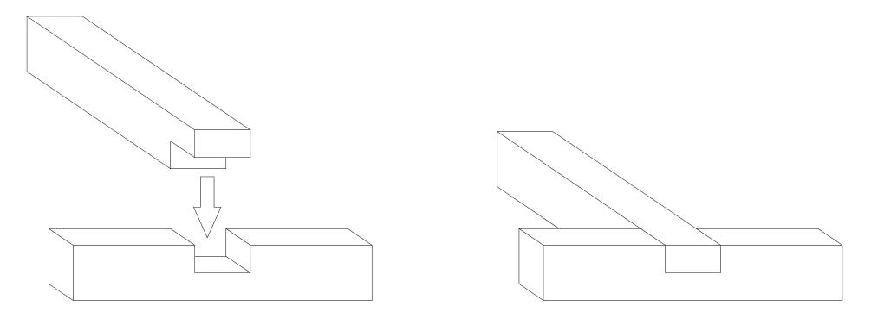Procedure:

1. Wooden blocks with dimensions 140x20x20 mm are cut as in the previous job.
2. Using the usual tools, marks are made in accordance with the diagram given.
3. For the female part, a hammer and a mortise teaser were used to create a hole in accordance with the dimensions marked. The finishing was done using the rasp file.
4. For the male part, a rip saw was used to cut along the marked line. Finishing again was done using a rasp file.
5. The two objects were hammered together and filed afterwards to achieve a smooth joint. If the objects don’t join, make necessary corrections.

## Job 3

Aim: To make a round cylinder from a cuboid, with dimensions 300x50x50 mm.

Materials Used:

1. Scale
2. Tryscale
3. Lathe Machine Tool
4. Outside Callipers

Procedure:

1. 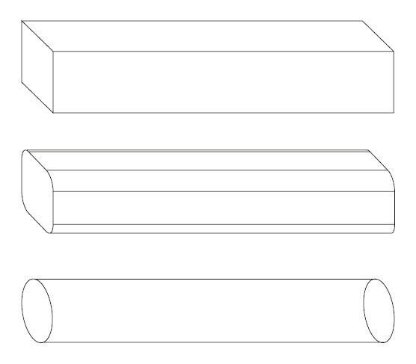Marked the wooden block with dimensions 300x50x50 mm using a pencil, a steel scale and a try scale, in accordance with the diagram shown.
2. The wooden block was then fixed in the horizontal position, with the end that has to be made circular.
3. The Iron Jack Plane was then run to achieve an approximately circular cross section as shown.
4. Now the wooden block is fixed in the Lathe machine and the machine’s turned on.
5. A firmer chisel is brought in contact with the rotating block to gradually convert it to a cylinder. At regular intervals, the circular part was checked to have the diameter, 30 mm, using an outside callieprs.